# **NC Innovation Center Detailed Report**

Peter Savitsky, Shea McIntee, Spurthi Kottan, Sruthi Saraswathy, Surabhi Seetharam and Qian Liu

# **Introduction**

The state of NC has a new Innovation Centre that aims at educating both staff and citizens with innovations and activities happening within the state. They have a plethora of statistical data collected from state to county level, but do not have the right interface to showcase the same in a way the general public can easily follow. Currently data queried is mostly numeric, in the form of tables. Although graphs can be generated, the current system is not intuitive.

# **Project Scope**

Create an interactive approach to represent this data. Target audience includes state employees and other residents who would visit the Innovation Center.

# **Project Phases**

**Data Visualization –** Our initial task was to identify suitable data visualizations which would interactively convey meaningful data to the audience. We considered several static options such as Heat Maps, Bar graphs, Google Fusion Tables and Colour Maps.

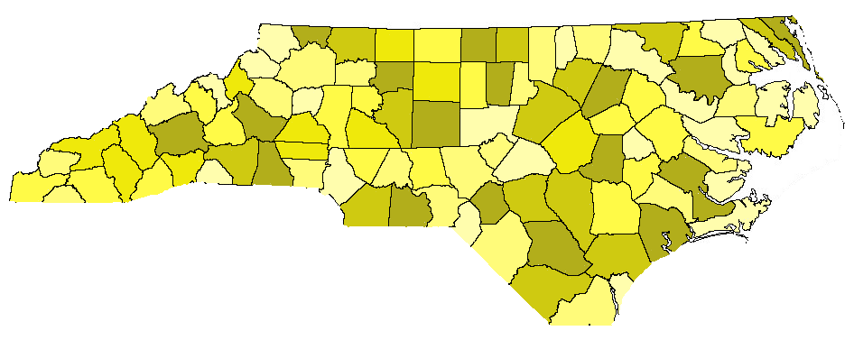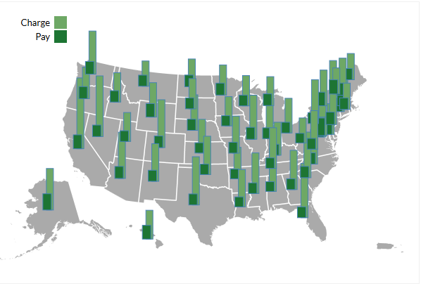

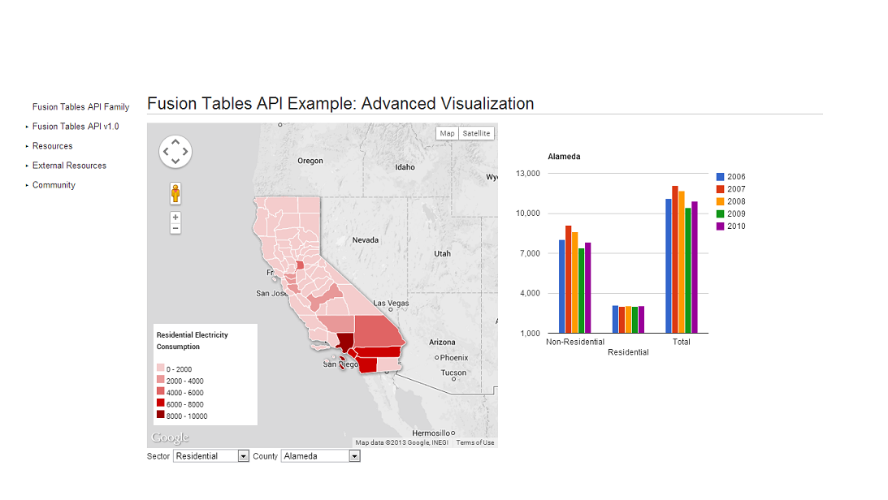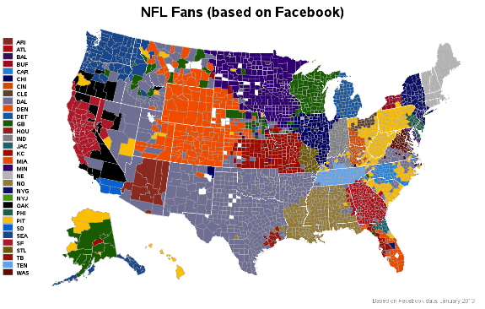

Beyond the above static options, we also worked with several dynamic options such as GapMinder, Ammaps, Google Motion Api and Cartograms.

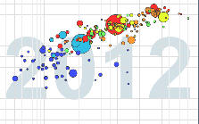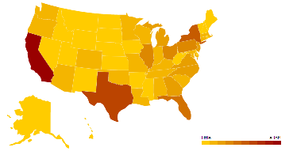

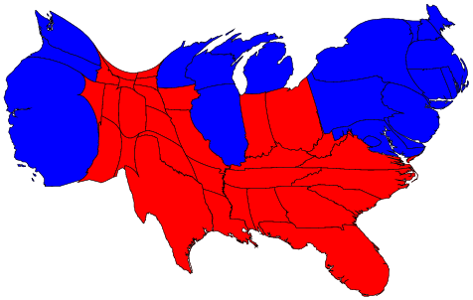

We finally narrowed in on the Ammaps and Google Motion API for our prototype implementation.

**Sketching**

The sketch below will be used as a general template for all following webpages.

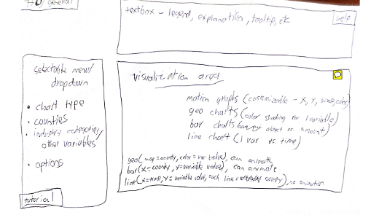

The sketches below depict the complete story and navigations to appropriate pages. 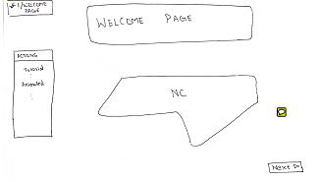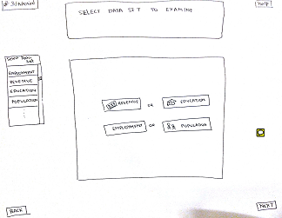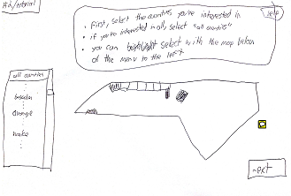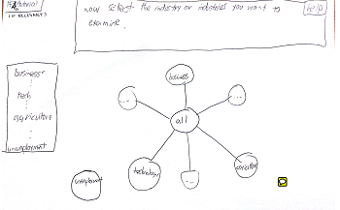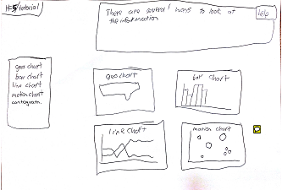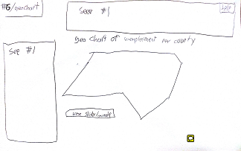

The aim was to have 2 modes of operation; the Animated and the Tutorial mode. Where tutorial mode would guide you through the system to select counties and appropriate data-sets, the animated mode (similar to a screensaver), which would have preselected datasets to iterate over and display results.

**Initial Prototype**

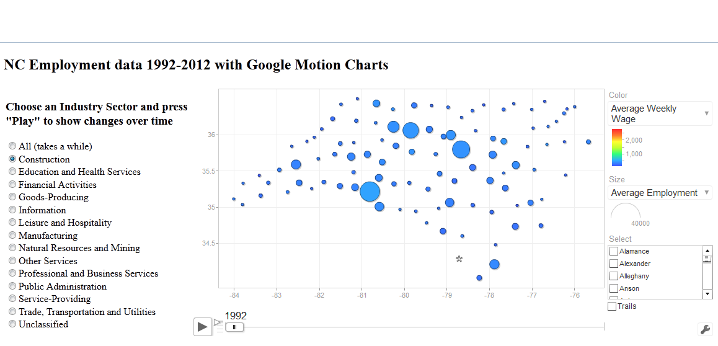

**Final Prototype**

In our final prototype, as seen below, we have incorporated more data granularity as desired by the clients and also multiple options to visualize requested data.

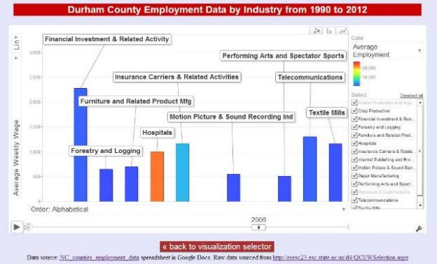

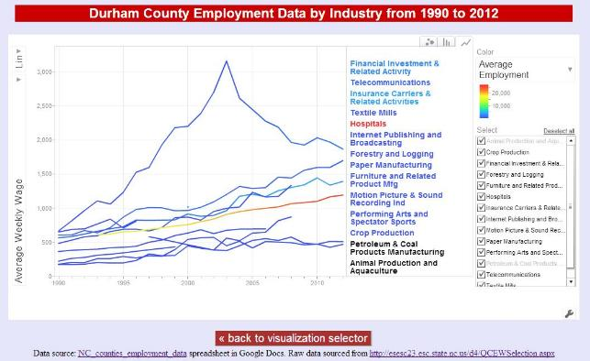

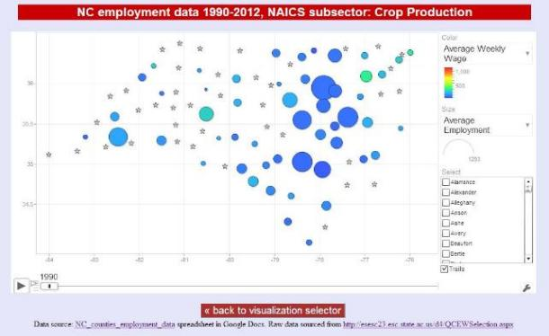

# **Project Evaluation**

**Participant Characteristics –** Choosing participants to evaluate this was a difficult task as it would have to cover people over a wide set of backgrounds and also different age groups. We have considered not only students but also working professionals from different backgrounds to complete the evaluation. A total of 13 participants in the age-group range was 23-40 consisting of both Male and Female participants were considered.

**Tasks**

1: Find the average weekly wage of employees in the construction industry for Wake county for the year 1995.

2: Find the average employment in the Forestry and Logging industry for Alamance county for the year 2000.

Apart from the above tasks the participants were explained one of the aims of the project i.e to keep people visiting the Innovation Center both informed and entertained. They were asked to play with the prototype and provide suggestions for improvement.

**Analysis of Evaluation Results**

No initial evaluation results were collected as there was no existing interface to be analyzed. The data evaluation suggestions and stories however were sent to the client for feedback. The final evaluation survey focused mainly on qualities such as Usability, Approachability and Learning. A few questions on Aesthetics were included to add completeness to the report. The emotional state of the participants was also captured before and after the survey. Along with this an overall rating for the prototype was also requested. All users were able to complete the tasks assigned.

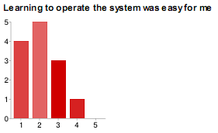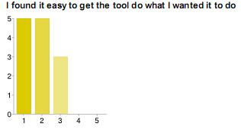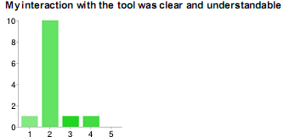

The survey results showed the prototype to be usable. Although a few participants had some difficulty understanding the category selection process, they were able to navigate through the rest of the tool without much difficulty.

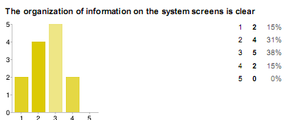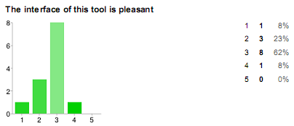

Our prototype did not fare very well on the aesthetics front and this was expected as we were unable to work much on this due to timing constraints. However, the participants really enjoyed the animation of ammaps and also the data bubbles of google motion. The appreciated having multiple ways to visualize the data.

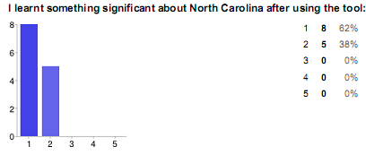

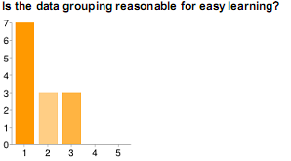

The prototype was a hit on the learning front as majority users really felt they learned something substantial about the counties of North Carolina and also about the local industries and employment trends.

The energy levels of majority the participants remained consistent both before and after the task.

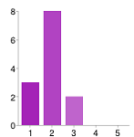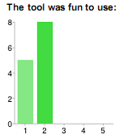 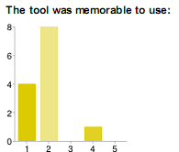

Overall, although most participants enjoyed using the tool and found it fun and memorable to use. Some provided valid feedback of re-arranging the category selection page. A few also suggested using pop-ups to help out when users are unclear of what something stood for. Due to timing constraints we were unable to implement all the suggestions provided by the users.

# **Conclusion**

Designing a brand new prototype for visually representing years of statistical data made this a very interesting project. The difficulty was incorporating the range and type of audience that would be using this tool. Considering that not only would it be on display for the public to play with would also be used by state employees for observing trends etc. was a challenging task. Although we were unable to focus much on the visual aesthetics, we were successfully able to display years of statistical data in a simple yet interactive manner. Overall, this was a fun filled learning experience where we were able to employ some design strategies learnt in this course, which I am sure will come in handy in all our future design endeavors.